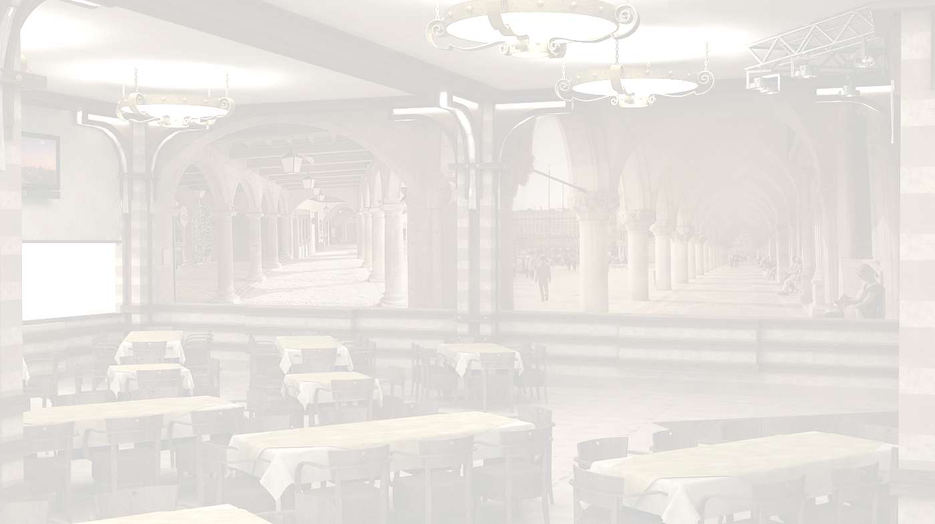
wvnianebi
Soups
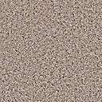CixirTma |  |  |  |  |  |  |  |  | 5.00 | lari
"Chikhirtma" A Light Chicken Broth With Chopped boiled Eggs and Heb’s |  |  |  |  |  |  |  |  | 5.00 | GEL
nivziani xarCo |  |  |  |  |  |  |  |  | 16.00 | lari
"Kharcho " With Walnuts |  |  |  |  |  |  |  |  | 16.00 | GEL
sokos supi |  |  |  |  |  |  |  |  | 5.50 | lari
Mushroom Soup |  |  |  |  |  |  |  |  | 5.50 | GEL
sokos krem-supi |  |  |  |  |  |  |  |  | 5.50 | lari
Mushroom Cream-Soup |  |  |  |  |  |  |  |  | 5.50 | GEL
pamidvris supi |  |  |  |  |  |  |  |  | 5.00 | lari
Tomato soup |  |  |  |  |  |  |  |  | 5.00 | GEL
kartofilis supi |  |  |  |  |  |  |  |  | 5.00 | lari
Potato Soup |  |  |  |  |  |  |  |  | 5.00 | GEL
ispanaxis supi |  |  |  |  |  |  |  |  | 5.00 | lari
Spinach Soup |  |  |  |  |  |  |  |  | 5.00 | GEL
comeuli
Main Dishes
puri |  |  |  |  |  |  |  |  | 1.20 | lari
Bread |  |  |  |  |  |  |  |  | 1.20 | GEL
mWadi |  |  |  |  |  |  |  |  | 1.00 | lari
Bread of maize flour |  |  |  |  |  |  |  |  | 1.00 | GEL
WviStari |  |  |  |  |  |  |  |  | 1.80 | lari
"Chvishtari" Bread of maize flour with "Sulguni" Cheese |  |  |  |  |  |  |  |  | 1.80 | GEL
“Romi” Sebolili yveliT |  |  |  |  |  |  |  |  | 4.50 | lari
“Gomi” Porridge of ground maize boiled with Smoked “Sulguni” Cheese |  |  |  |  |  |  |  |  | 4.50 | GEL
“elarji” |  |  |  |  |  |  |  |  | 8.00 | lari
“Elargi” Corn Porridge With “Sulduni” Cheese |  |  |  |  |  |  |  |  | 8.00 | GEL
xaWapuri imeruli |  |  |  |  |  |  |  |  | 8.00 | lari
Khachapuri “imeruli” Traditional Georgian pie with Imeruli cheese |  |  |  |  |  |  |  |  | 8.00 | GEL
xaWapuri megruli |  |  |  |  |  |  |  |  | 10.00 | lari
Khachapuri “megruli” Traditional Georgian pie with” sulgun”i and “ Imerul”i cheese |  |  |  |  |  |  |  |  | 10.00 | GEL
lobiani |  |  |  |  |  |  |  |  | 5.50 | lari
"lobiani" Traditional Georgian pie with ”with red bean" |  |  |  |  |  |  |  |  | 5.50 | GEL
xinkali (xocis, sokos an yvelis Tqveni arCeviT)  |  |  |  |  |  |  |  |  | 0.60 | lari
”Khinkali” Georgian Style pasta pockets filled with minced meat, Mushroom or Cheese |  |  |  |  |  |  |  |  | 0.60 | GEL
xinkali sokos an yvelis (Tqveni arCeviT) |  |  |  |  |  |  |  |  | 0.90 | lari
”Khinkali” Georgian Style pasta pockets filled with Mushroom or Cheese |  |  |  |  |  |  |  |  | 0.90 | GEL
pica  saerTo yvela picisTvis: pamidori, mocarela da oregano  da Tqveni arCevani:xaxvi, soko, tkbili wiwaka, Cili, ananasi, simindis marcvlebi, anCousi, “lurji” yveli, qaTami, bekoni, moxarSuli lori, zeTisxili,artiSoki, CaSuSuli ispanaxi, Tinusi |  |  |  | Pizza  CornerBase pizza with Mozzarella, tomato and oregano Plus your choice of toppings:  onions, mushrooms, bell pepper, chili,  pineapple, sweet corn, anchovies, blue cheese, chicken, salami, crispy bacon,  cooked ham olives, artichokes, sautéed  spinach, garlic, tuna
 |  |  |  |  |  |  |  |  | 24.00 | lari
 |  |  |  |  |  |  |  |  | 24.00 | GEL
cxare  spicy |  | vegeterianuli  vegetarian |  | alkoholuri  Cortains alcohol |  | 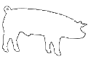  Roris xorci  pork |  |  19:00 saaTamde  Till 19:00
visac dietis an alergiis gamo surs icodes sakvebis Semadgenloba, gTxovT mimarToT mimtans
For those with special dietary requirements or allergies, please ask our waiter for assistance
momsaxureoba-15%
service charge-15%

